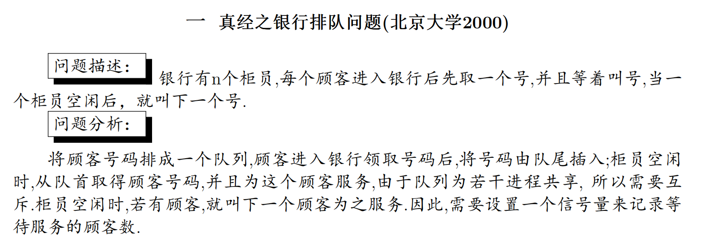

semaphore mutex = 1;          *// 保护队列的互斥锁*

semaphore customer_count = 0;  *// 等待服务的顾客数量*

cobegin

*// 顾客进程*

    process Customer {

        while (true) {

            取号码;

            P(mutex);          *// 申请队列访问权*

            进入队列;

            V(mutex);          *// 释放队列访问权*

            V(customer_count); *// 增加等待顾客数*

        }

    }

*// 柜员进程（i=1,2,...,n）*

    process Server {

        while (true) {

            P(customer_count);  *// 等待顾客到来*

            P(mutex);          *// 申请队列访问权*

            从队列中取下一个号码;

            V(mutex);         *// 释放队列访问权*

            为该号码持有者服务;

        }

    }

coend

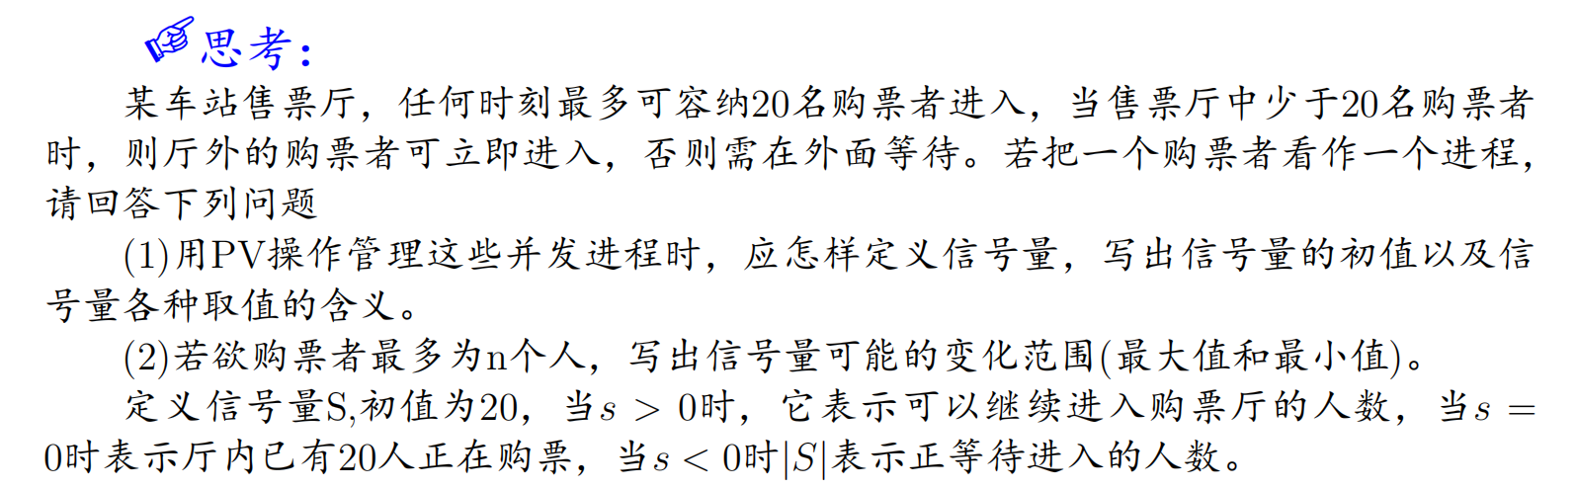

semaphore S = 20;  *// 控制售票厅容量的信号量，初始值为20*

cobegin

    process Buyer {

        while (true) {

            P(S);               *// 申请进入售票厅*

*// 进入并购票*

            进入售票厅并购票;

            V(S);               *// 离开售票厅*

        }

    }

coend

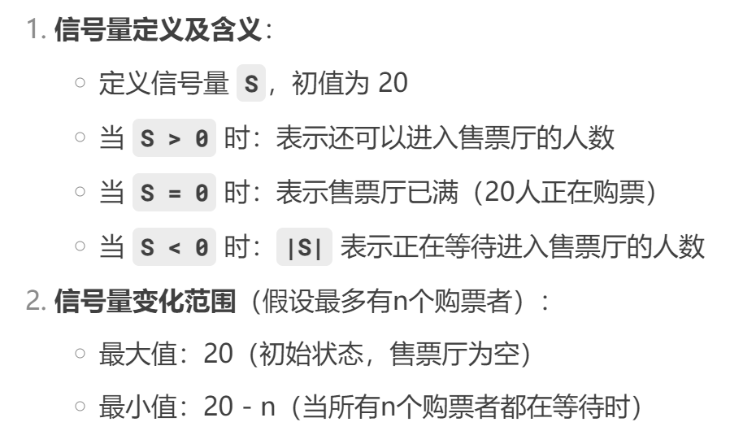

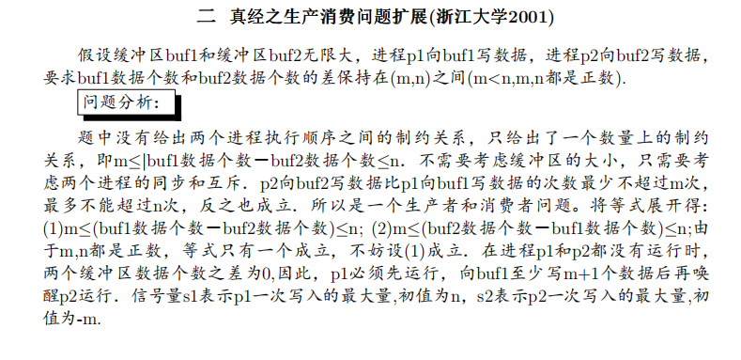

semaphore mutex1 = 1;  *// 保护 buf1 的互斥锁*

semaphore mutex2 = 1;  *// 保护 buf2 的互斥锁*

semaphore s1 = n;      *// p1 最多领先 p2 n 个数据*

semaphore s2 = -m;     *// p2 最多领先 p1 m 个数据*

cobegin

*// 进程 p1：向 buf1 写入数据*

    process p1 {

        while (true) {

            get_data();          *// 获取数据*

            P(s1);              *// 检查是否允许写入（防止 buf1 比 buf2 多超过 n 个）*

            P(mutex1);         *// 申请 buf1 访问权*

            写入数据到 buf1;

            V(mutex1);         *// 释放 buf1 访问权*

            V(s2);             *// 允许 p2 写入（buf2 可以追赶）*

        }

    }

*// 进程 p2：向 buf2 写入数据*

    process p2 {

        while (true) {

            get_data();          *// 获取数据*

            P(s2);              *// 检查是否允许写入（防止 buf2 比 buf1 多超过 m 个）*

            P(mutex2);         *// 申请 buf2 访问权*

            写入数据到 buf2;

            V(mutex2);         *// 释放 buf2 访问权*

            V(s1);             *// 允许 p1 写入（buf1 可以追赶）*

        }

    }

coend

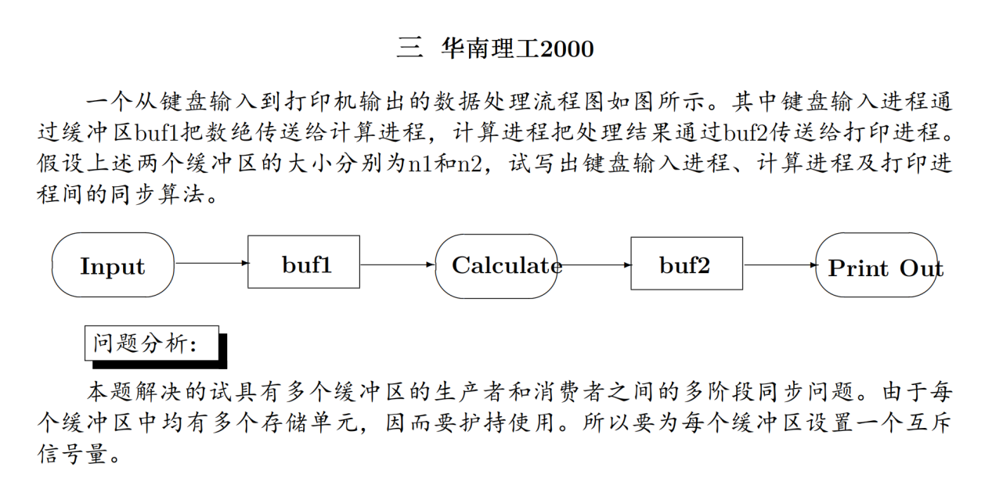

semaphore empty1 = n1;  *// buf1剩余空间（初始为n1）*

semaphore full1 = 0;    *// buf1已有数据量（初始为0）*

semaphore mutex1 = 1;   *// buf1互斥锁*

semaphore empty2 = n2;  *// buf2剩余空间（初始为n2）*

semaphore full2 = 0;    *// buf2已有数据量（初始为0）*

semaphore mutex2 = 1;   *// buf2互斥锁*

cobegin

*// 键盘输入进程（生产者）*

    process Input {

        while (true) {

            从键盘读取数据;

            P(empty1);       *// 检查buf1是否有空间*

            P(mutex1);      *// 申请buf1的互斥访问*

            将数据写入buf1;

            V(mutex1);      *// 释放buf1的互斥访问*

            V(full1);       *// 通知计算进程buf1有新数据*

        }

    }

*// 计算进程（既是消费者又是生产者）*

    process Calculate {

        while (true) {

            P(full1);       *// 检查buf1是否有数据*

            P(mutex1);      *// 申请buf1的互斥访问*

            从buf1读取数据;

            V(mutex1);      *// 释放buf1的互斥访问*

            V(empty1);      *// 释放buf1的空间*

            计算数据;        *// 核心计算逻辑*

            P(empty2);      *// 检查buf2是否有空间*

            P(mutex2);      *// 申请buf2的互斥访问*

            将计算结果写入buf2;

            V(mutex2);      *// 释放buf2的互斥访问*

            V(full2);       *// 通知打印进程buf2有新数据*

        }

    }

*// 打印进程（消费者）*

    process Print_Out {

        while (true) {

            P(full2);       *// 检查buf2是否有数据*

            P(mutex2);      *// 申请buf2的互斥访问*

            从buf2读取数据;

            V(mutex2);      *// 释放buf2的互斥访问*

            V(empty2);      *// 释放buf2的空间*

            打印数据;       *// 输出结果*

        }

    }

coend

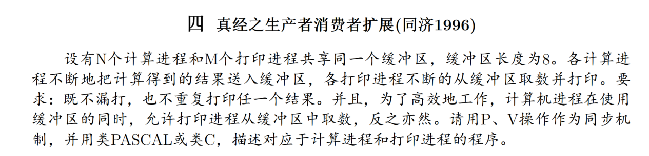

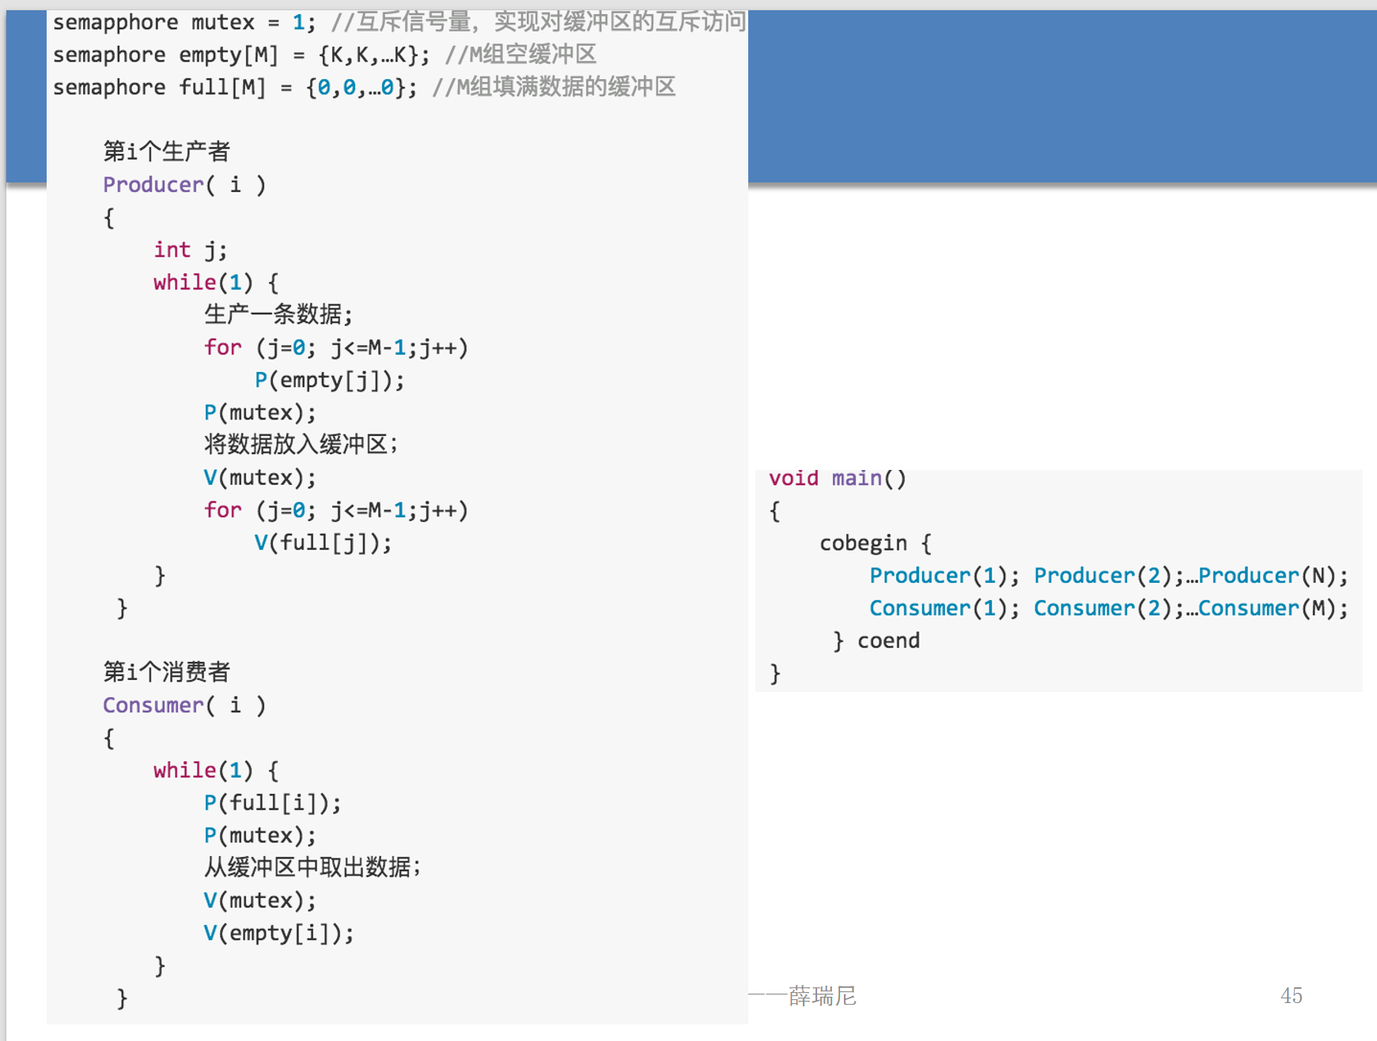

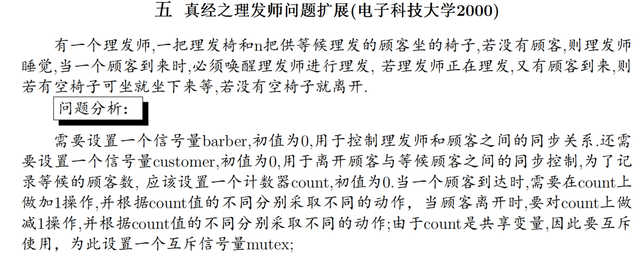

int count = 0;          *// 共享变量：等待的顾客数*

semaphore mutex = 1;     *// 互斥锁，保护count*

semaphore barber = 0;    *// 理发师信号量（初始无顾客）*

semaphore customer = 0;  *// 顾客信号量（初始无理发师）*

cobegin

*// 理发师进程*

    process barber {

        while (true) {

            P(customer);    *// 等待顾客到来（若无顾客则阻塞）*

            P(mutex);       *// 进入临界区*

            count--;        *// 减少等待顾客数*

            V(barber);      *// 允许顾客开始理发*

            V(mutex);      *// 退出临界区*

            理发;          *// 实际理发操作（临界区外）*

        }

    }

*// 顾客进程*

    process customer {

        P(mutex);           *// 进入临界区*

        if (count < n) {    *// 检查是否有空椅子*

            count++;        *// 增加等待顾客数*

            V(customer);    *// 唤醒理发师（若在睡觉）*

            V(mutex);       *// 退出临界区*

            P(barber);      *// 等待理发师就绪*

            理发;          *// 接受理发服务*

        } else {

            V(mutex);       *// 退出临界区（无空椅子）*

            离开;          *// 直接离开*

        }

    }

coend

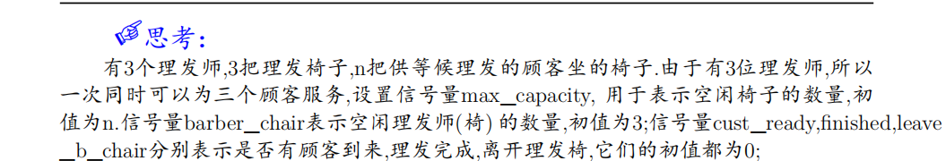

semaphore max_capacity = n;    *// 空闲等候椅数量（初值n）*

semaphore barber_chair = 3;    *// 空闲理发椅数量（初值3）*

semaphore cust_ready = 0;      *// 顾客就绪信号（初值0）*

semaphore finished = 0;        *// 理发完成信号（初值0）*

semaphore leave_b_chair = 0;   *// 离开理发椅信号（初值0）*

cobegin

*// 理发师进程（3个并发实例）*

    process barber {

        while (true) {

            P(cust_ready);     *// 等待顾客就绪*

            理发;

            V(finished);       *// 通知理发完成*

            P(leave_b_chair);  *// 等待顾客离开理发椅*

        }

    }

*// 顾客进程*

    process customer {

        P(max_capacity);       *// 尝试占用等候椅（若无空闲则阻塞）*

        进入店里;

        P(barber_chair);       *// 尝试占用理发椅（若无空闲则阻塞）*

        坐在理发椅上;

        V(cust_ready);         *// 通知理发师有顾客*

        P(finished);           *// 等待理发完成*

        离开理发椅;

        V(leave_b_chair);      *// 通知已离开理发椅*

        V(barber_chair);       *// 释放理发椅*

        离开店;

        V(max_capacity);       *// 释放等候椅*

    }

coend

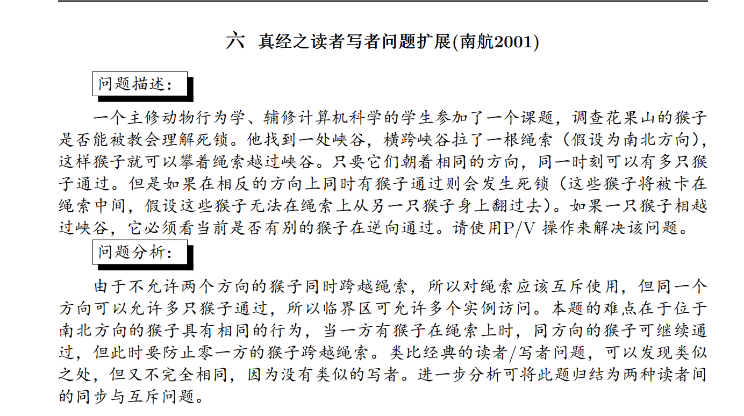

semaphore mutex = 1;        *// 绳索全局互斥锁（初值1）*

semaphore Smutex = 1;       *// 南向猴子计数器互斥锁（初值1）*

semaphore Nmutex = 1;       *// 北向猴子计数器互斥锁（初值1）*

int SmonkeyCount = 0;       *// 南向北的猴子数量（共享变量）*

int NmonkeyCount = 0;       *// 北向南的猴子数量（共享变量）*

cobegin

*// 南向北的猴子进程（i=1,2,3,...）*

process SouthMonkey {

While(true){

        P(Smutex);                     *// 获取南向计数器锁*

        if (SmonkeyCount == 0) {       *// 如果是第一个南向猴子*

            P(mutex);                  *// 尝试独占绳索（阻止北向猴子）*

        }

        SmonkeyCount++;                *// 增加南向猴子计数*

        V(Smutex);                     *// 释放南向计数器锁*

        攀越绳索;                     *// 实际过峡谷操作*

        P(Smutex);                     *// 获取南向计数器锁*

        SmonkeyCount--;                *// 减少南向猴子计数*

        if (SmonkeyCount == 0) {       *// 如果是最后一个南向猴子*

            V(mutex);                  *// 释放绳索控制权*

        }

        V(Smutex);

}                    *// 释放南向计数器锁*

    }

*// 北向南的猴子进程（j=1,2,3,...）*

process NorthMonkey {

While(true){

        P(Nmutex);                     *// 获取北向计数器锁*

        if (NmonkeyCount == 0) {       *// 如果是第一个北向猴子*

            P(mutex);                  *// 尝试独占绳索（阻止南向猴子）*

        }

        NmonkeyCount++;                *// 增加北向猴子计数*

        V(Nmutex);                     *// 释放北向计数器锁*

        攀越绳索;                     *// 实际过峡谷操作*

        P(Nmutex);                     *// 获取北向计数器锁*

        NmonkeyCount--;                *// 减少北向猴子计数*

        if (NmonkeyCount == 0) {       *// 如果是最后一个北向猴子*

            V(mutex);                  *// 释放绳索控制权*

        }

        V(Nmutex);

}                    *// 释放北向计数器锁*

    }

coend

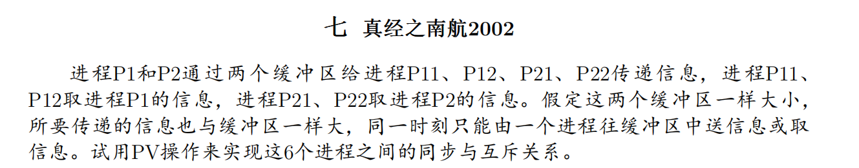

semaphore mutex = 1;        *// 缓冲区操作互斥锁（初值1）*

semaphore empty1 = 1;       *// 缓冲区1空闲信号（初值1）*

semaphore empty2 = 1;       *// 缓冲区2空闲信号（初值1）*

semaphore full1 = 0;        *// 缓冲区1数据就绪信号（初值0）*

semaphore full2 = 0;        *// 缓冲区2数据就绪信号（初值0）*

semaphore S11 = 0, S12 = 0; *// P11/P12专用取数信号*

semaphore S21 = 0, S22 = 0; *// P21/P22专用取数信号*

cobegin

*// 生产者P1（向缓冲区1写数据）*

process P1 {

While(true){

        P(empty1);                  *// 等待缓冲区1空闲*

        P(mutex);                   *// 获取缓冲区操作权*

        put_message_into_buff1();   *// 写入数据到缓冲区1*

        V(mutex);                   *// 释放缓冲区操作权*

        V(S11);                     *// 通知P11可读取*

        V(S12);                     *// 通知P12可读取*

        V(full1);

}                   *// 标记缓冲区1数据就绪*

    }

*// 生产者P2（向缓冲区2写数据）*

process P2 {

While(true){

        P(empty2);                  *// 等待缓冲区2空闲*

        P(mutex);                   *// 获取缓冲区操作权*

        put_message_into_buff2();   *// 写入数据到缓冲区2*

        V(mutex);                   *// 释放缓冲区操作权*

        V(S21);                     *// 通知P21可读取*

        V(S22);                     *// 通知P22可读取*

        V(full2);                   *// 标记缓冲区2数据就绪*

}

}

*// 消费者P11（从缓冲区1读数据）*

process P11 {

While(true){

        P(full1);                   *// 等待缓冲区1数据就绪*

        P(S11);                     *// 检查P1是否允许本进程读取*

        P(mutex);                   *// 获取缓冲区操作权*

        get_message_from_buff1();   *// 从缓冲区1读取数据*

        V(mutex);                   *// 释放缓冲区操作权*

        V(empty1);

}                 *// 标记缓冲区1空闲*

    }

*// 消费者P12（从缓冲区1读数据）*

process P12 {

While(true){

        P(full1);                   *// 等待缓冲区1数据就绪*

        P(S12);                     *// 检查P1是否允许本进程读取*

        P(mutex);                   *// 获取缓冲区操作权*

        get_message_from_buff1();   *// 从缓冲区1读取数据*

        V(mutex);                   *// 释放缓冲区操作权*

        V(empty1);                  *// 标记缓冲区1空闲*

}

}

*// 消费者P21（从缓冲区2读数据）*

process P21 {

While(true){

        P(full2);                   *// 等待缓冲区2数据就绪*

        P(S21);                     *// 检查P2是否允许本进程读取*

        P(mutex);                   *// 获取缓冲区操作权*

        get_message_from_buff2();   *// 从缓冲区2读取数据*

        V(mutex);                   *// 释放缓冲区操作权*

        V(empty2);

}                *// 标记缓冲区2空闲*

    }

*// 消费者P22（从缓冲区2读数据）*

process P22 {

While(true){

        P(full2);                   *// 等待缓冲区2数据就绪*

        P(S22);                     *// 检查P2是否允许本进程读取*

        P(mutex);                   *// 获取缓冲区操作权*

        get_message_from_buff2();   *// 从缓冲区2读取数据*

        V(mutex);                   *// 释放缓冲区操作权*

        V(empty2);                  *// 标记缓冲区2空闲*

}

}

coend

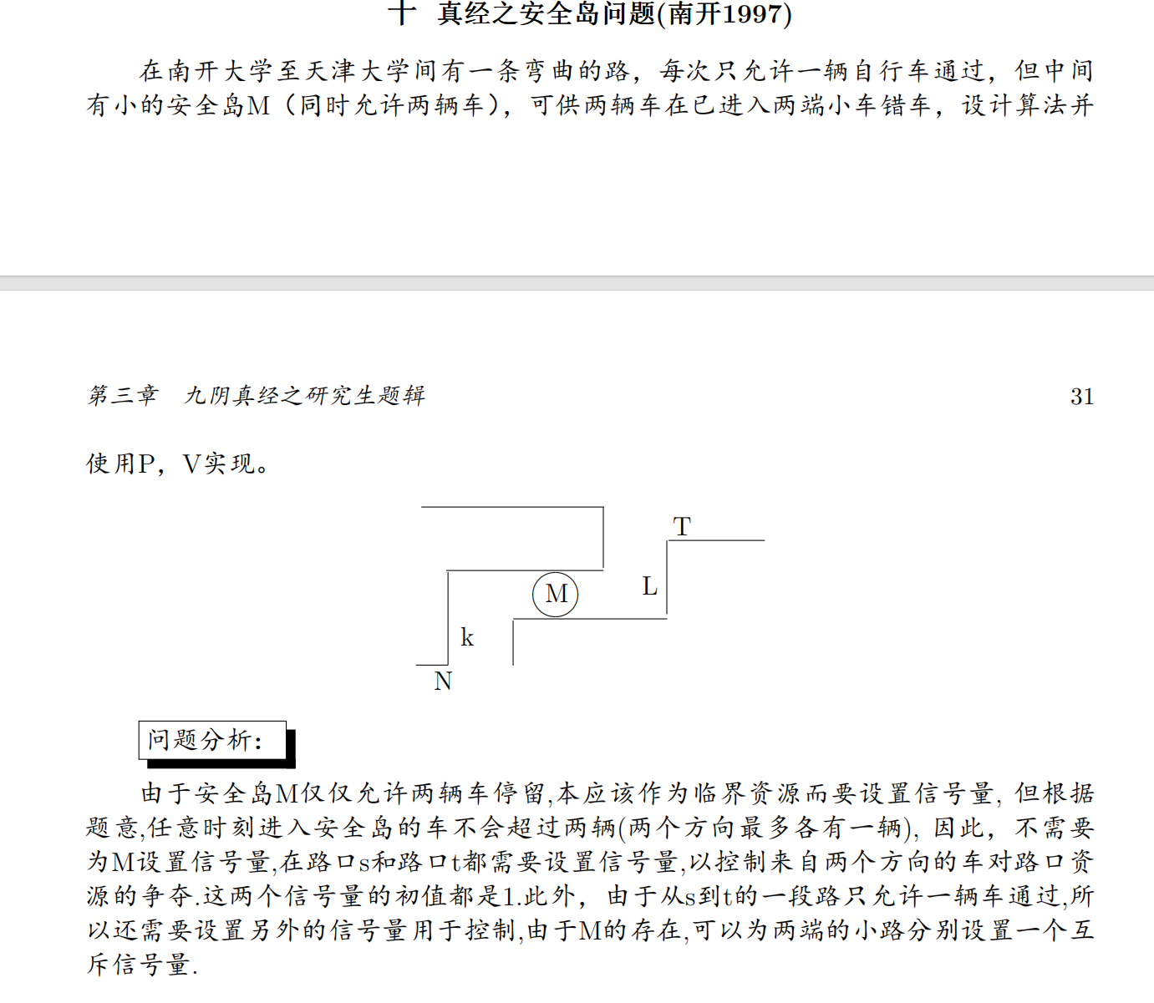

semaphore T2N = 1;  *// 南开→天津方向路口控制*

semaphore N2T = 1;  *// 天津→南开方向路口控制*

semaphore L = 1;     *// 南开→安全岛路段*

semaphore K = 1;     *// 天津→安全岛路段*

semaphore M = 2;     *// 安全岛容量*

cobegin

procedure Bike_T2N(){  *// 南开→天津方向*

  While(true){

        P(T2N);

        P(L);

*// 从T行驶到L路段*

        P(M);

*// 进入安全岛M*

        V(L);

        P(K);

*// 从K路段行驶到S*

        V(M);

        V(K);

        V(T2N);

}

}

    procedure Bike_N2T()  *// 天津→南开方向*

     {

While(true){

P(N2T);

        P(K);

*// 从S行驶到K路段*

        P(M);

*// 进入安全岛M*

        V(K);

        P(L);

*// 从L路段行驶到T*

        V(M);

        V(L);

        V(N2T);

}

}

coend

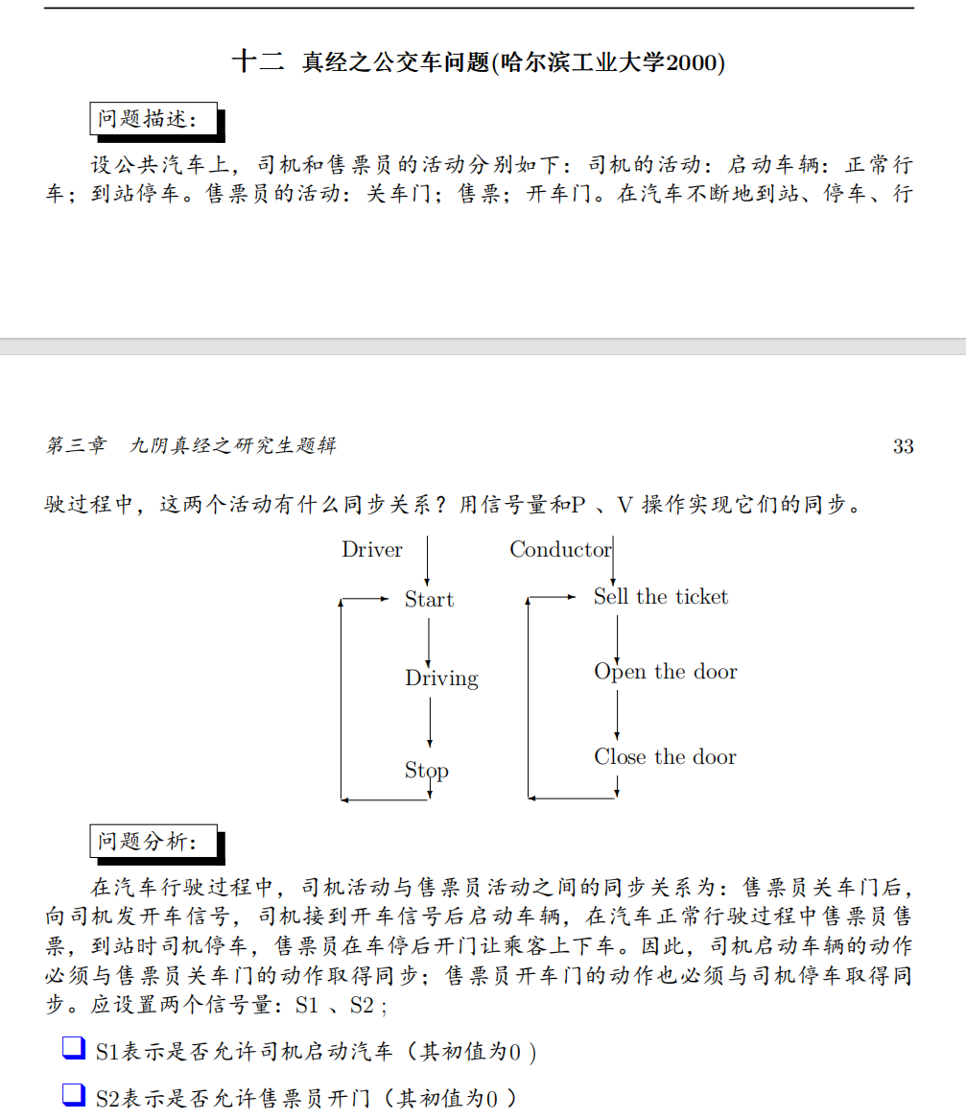

semaphore S1 = 0;  *// 允许司机启动的信号（售票员关门后触发）*

semaphore S2 = 0;  *// 允许售票员开门的信号（司机停车后触发）*

cobegin

    procedure Driver() {

        while(TRUE) {

            P(S1);       *// 等待售票员关门*

            Start();     *// 启动车辆*

            Driving();   *// 正常行驶*

            Stop();      *// 到站停车*

            V(S2);       *// 通知售票员可以开门*

        }

    }

    procedure Conductor() {

        while(TRUE) {

            CloseDoor(); *// 关闭车门*

            V(S1);      *// 通知司机可以启动*

            SellTicket();*// 售票*

            P(S2);       *// 等待司机停车*

            OpenDoor();  *// 打开车门*

            Passenger(); *// 乘客上下车*

        }

    }

coend

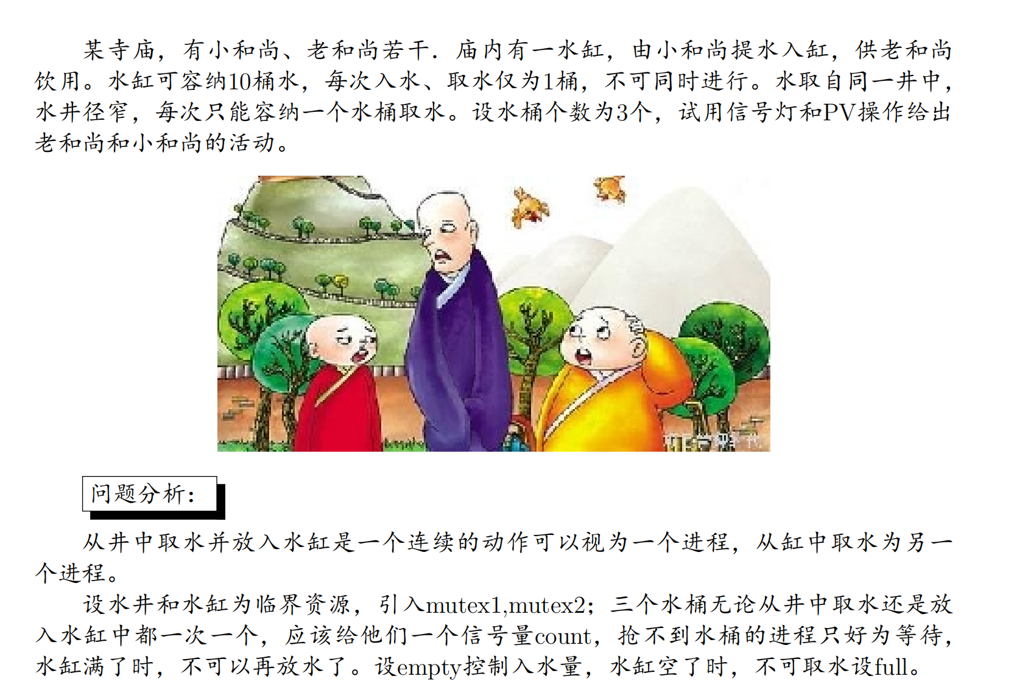

semaphore mutex1 = 1;  *// 水井互斥锁*

semaphore mutex2 = 1;  *// 水缸互斥锁*

semaphore empty = 10;  *// 水缸剩余容量（初始可装10桶）*

semaphore full = 0;    *// 水缸当前水量*

semaphore count = 3;   *// 可用水桶数量*

cobegin

    procedure Fetch_Water() {  *// 小和尚打水*

        while(TRUE) {

            P(empty);         *// 检查水缸是否有空位*

            P(count);         *// 获取水桶*

            P(mutex1);        *// 申请水井使用权*

            GetWaterFromWell();  *// 从井中取水*

            V(mutex1);        *// 释放水井*

            P(mutex2);        *// 申请水缸使用权*

            PourIntoJar();    *// 将水倒入水缸*

            V(mutex2);        *// 释放水缸*

            V(count);         *// 归还水桶*

            V(full);          *// 增加水缸水量计数*

        }

    }

    procedure Drink_Water() {  *// 老和尚喝水*

        while(TRUE) {

            P(full);          *// 检查水缸是否有水*

            P(count);         *// 获取水桶*

            P(mutex2);        *// 申请水缸使用权*

            GetWaterFromJar();  *// 从缸中取水*

            Drink();          *// 喝水*

            V(mutex2);        *// 释放水缸*

            V(empty);         *// 增加水缸空位*

            V(count);         *// 归还水桶*

        }

    }

coend

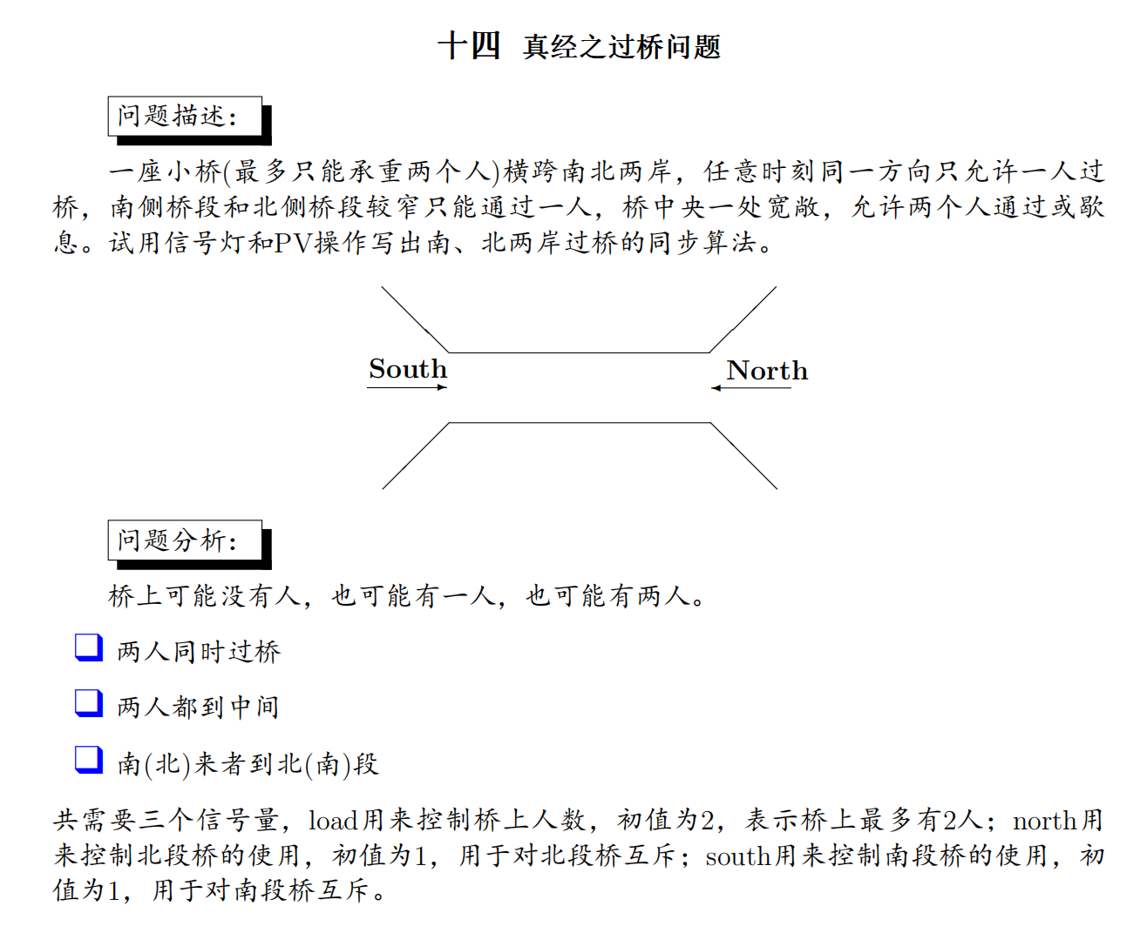

semaphore load = 2;   *// 桥上最大承载人数*

semaphore north = 1;  *// 北段桥互斥锁*

semaphore south = 1;  *// 南段桥互斥锁*

process SouthToNorth() {

While(true){

    P(load);

    P(north);

*通过北段桥*

*到达桥中央*

    V(north);

    P(south);

*通过南段桥*

*到达南岸*

    V(south);

V(load);

}

}

process NorthToSouth() {

While(true){

    P(load);

    P(south);

*通过南段桥*

*到达桥中央*

    V(south);

    P(north);

*通过北段桥*

*到达北岸*

    V(north);

V(load);

}

}

cobegin

    SouthToNorth();  *// 南向北过桥进程*

    NorthToSouth();  *// 北向南过桥进程*

coend

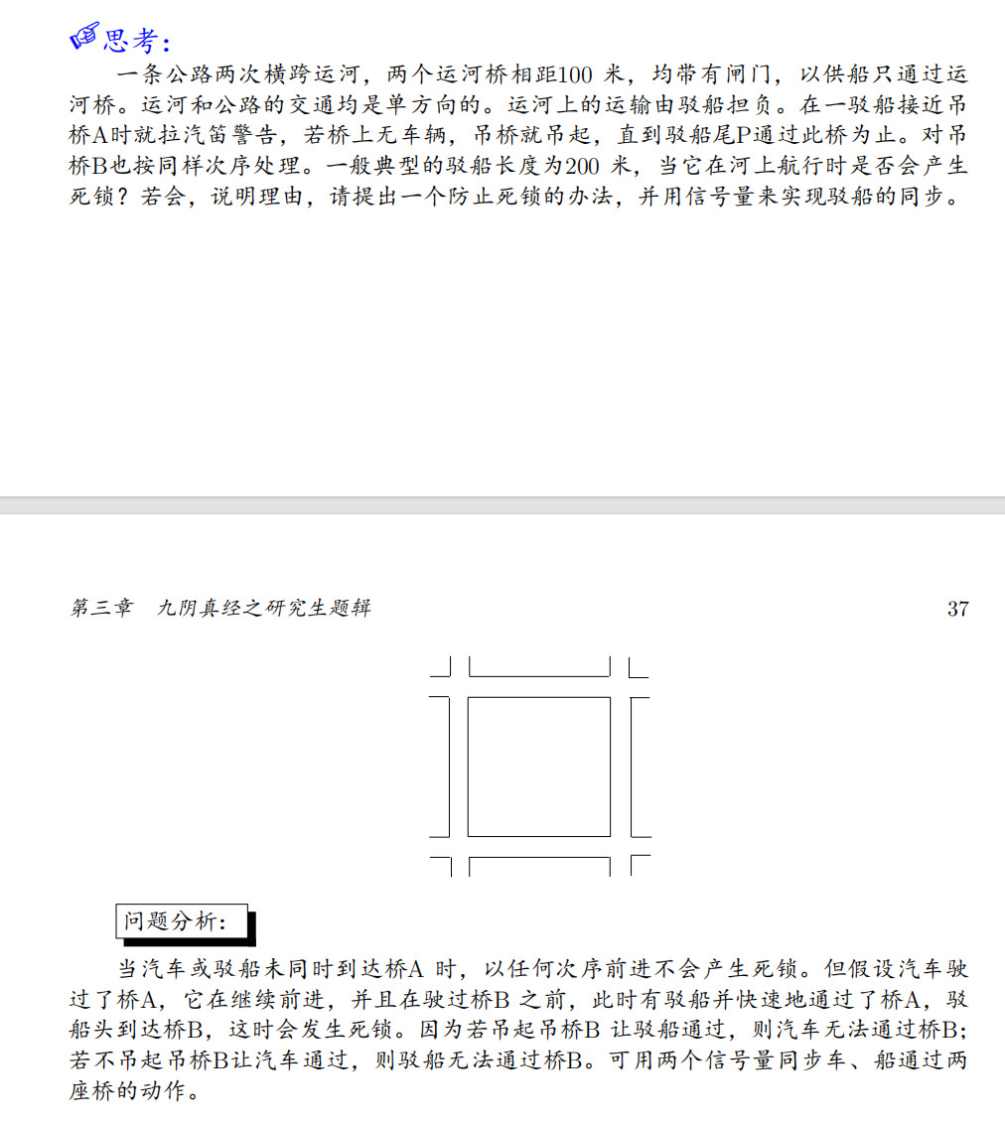

semaphore Sa = 1;  *// 控制桥A的访问*

semaphore Sb = 1;  *// 控制桥B的访问*

cobegin

barge_process() {

While(true){

    P(Sa);  *// 申请桥A*

    P(Sb);  *// 申请桥B*

*// 驳船依次通过桥A和桥B*

    V(Sa);  *// 释放桥A*

    V(Sb);  *// 释放桥B*

}

}

car_process() {

  While(true){

P(Sa);  *// 申请桥A*

    P(Sb);  *// 申请桥B*

*// 汽车依次通过桥A和桥B*

    V(Sa);  *// 释放桥A*

    V(Sb);  *// 释放桥B*

}

}

coend

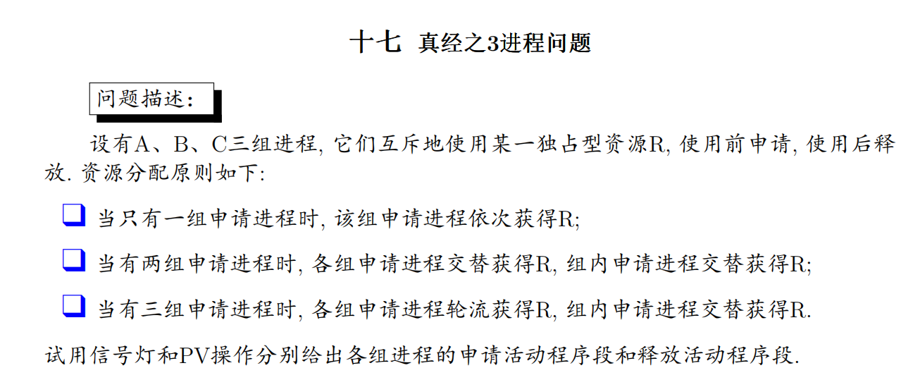

*// 信号量和变量定义*

semaphore mutex = 1;

semaphore qa = 0, qb = 0, qc = 0;

int Free = 1;

int counta = 0, countb = 0, countc = 0;

A_apply() {

 while(true){

    P(mutex);

    if (Free == 1) {

        Free = 0;

        V(mutex);

    } else {

        counta++;

        V(mutex);

        P(qa);

    }

 }

}

A_release() {

 while(true){

    if (countb > 0) {

        countb--;

        V(qb);

    } else if (countc > 0) {

        countc--;

        V(qc);

    } else if (counta > 0) {

        counta--;

        V(qa);

    } else {

        Free = 1;

    }

 }

}

B_apply() {

 while(true){

    P(mutex);

    if (Free == 1) {

        Free = 0;

        V(mutex);

    } else {

        countb++;

        V(mutex);

        P(qb);

    }

 }

}

B_release() {

 while(true){

    if (counta > 0) {

        counta--;

        V(qa);

    } else if (countc > 0) {

        countc--;

        V(qc);

    } else if (countb > 0) {

        countb--;

        V(qb);

    } else {

        Free = 1;

    }

 }

}

C_apply() {

 while(true){

    P(mutex);

    if (Free == 1) {

        Free = 0;

        V(mutex);

    } else {

        countc++;

        V(mutex);

        P(qc);

    }

 }

}

C_release() {

 while(true){

    if (counta > 0) {

        counta--;

        V(qa);

    } else if (countb > 0) {

        countb--;

        V(qb);

    } else if (countc > 0) {

        countc--;

        V(qc);

    } else {

        Free = 1;

    }

 }

}

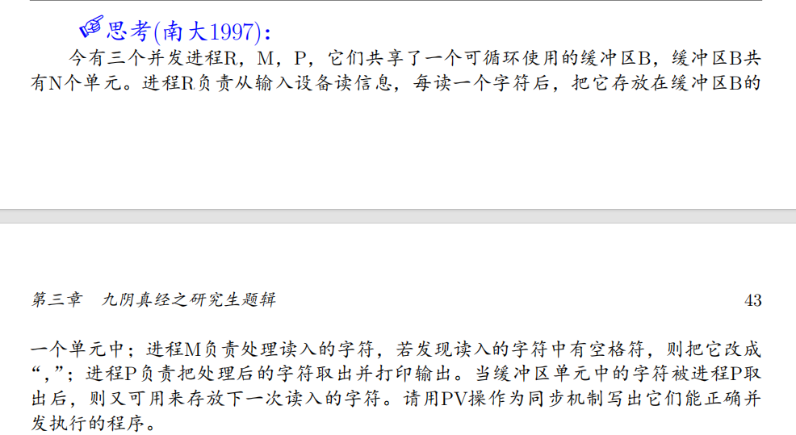

semaphore empty = N;  *// 初始空缓冲区数量*

semaphore full1 = 0;  *// R→M 的待处理数据*

semaphore full2 = 0;  *// M→P 的待输出数据*

semaphore mutex = 1;  *// 互斥锁*

char buffer[N];

int in = 0, out1 = 0, out2 = 0;

cobegin

    procedure R {

        while (1) {

            char x = read_char();  *// 读入字符*

            P(empty);             *// 申请空缓冲区*

            P(mutex);             *// 进入临界区*

            buffer[in] = x;        *// 写入数据*

            in = (in + 1) % N;

            V(mutex);             *// 离开临界区*

            V(full1);             *// 通知 M 可以处理*

        }

    }

    procedure M {

        while (1) {

            P(full1);             *// 等待 R 写入数据*

            P(mutex);

            char x = buffer[out1];

            if (x == ' ') x = ',';  *// 处理空格*

            buffer[out1] = x;

            out1 = (out1 + 1) % N;

            V(mutex);

            V(full2);             *// 通知 P 可以输出*

        }

    }

    procedure P {

        while (1) {

            P(full2);             *// 等待 M 处理完数据*

            P(mutex);

            char x = buffer[out2];

            out2 = (out2 + 1) % N;

            V(mutex);

            V(empty);             *// 释放缓冲区，通知 R 可写*

            print(x);            *// 输出字符*

        }

    }

coend

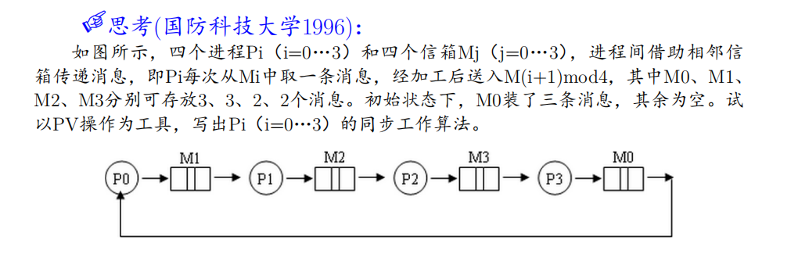

semaphore mutex0 = 1, mutex1 = 1, mutex2 = 1, mutex3 = 1;  *// 互斥访问信箱*

semaphore empty0 = 0, empty1 = 3, empty2 = 2, empty3 = 2;   *// 信箱剩余容量*

semaphore full0 = 3, full1 = 0, full2 = 0, full3 = 0;       *// 信箱当前消息数*

int in0 = 0, in1 = 0, in2 = 0, in3 = 0;     *// 写入指针*

int out0 = 0, out1 = 0, out2 = 0, out3 = 0;  *// 读取指针*

cobegin

    procedure P0 {

        while (1) {

            P(full0);               *// 等待M0有消息*

            P(mutex0);              *// 进入M0临界区*

            char msg = M0[out0];    *// 从M0取消息*

            out0 = (out0 + 1) % 3;  *// 更新读取指针*

            V(mutex0);

            V(empty0);              *// 释放M0空位*

            process_msg(&msg);      *// 加工消息*

            P(empty1);              *// 等待M1有空位*

            P(mutex1);

            M1[in1] = msg;          *// 写入M1*

            in1 = (in1 + 1) % 3;

            V(mutex1);

            V(full1);               *// 通知M1有新消息*

        }

    }

    procedure P1 {

        while (1) {

            P(full1);               *// 等待M1有消息*

            P(mutex1);

            char msg = M1[out1];

            out1 = (out1 + 1) % 3;

            V(mutex1);

            V(empty1);

            process_msg(&msg);

            P(empty2);              *// 等待M2有空位*

            P(mutex2);

            M2[in2] = msg;

            in2 = (in2 + 1) % 2;

            V(mutex2);

            V(full2);

        }

    }

    procedure P2 {

        while (1) {

            P(full2);              *// 等待M2有消息*

            P(mutex2);

            char msg = M2[out2];

            out2 = (out2 + 1) % 2;

            V(mutex2);

            V(empty2);

            process_msg(&msg);

            P(empty3);             *// 等待M3有空位*

            P(mutex3);

            M3[in3] = msg;

            in3 = (in3 + 1) % 2;

            V(mutex3);

            V(full3);

        }

    }

    procedure P3 {

        while (1) {

            P(full3);              *// 等待M3有消息*

            P(mutex3);

            char msg = M3[out3];

            out3 = (out3 + 1) % 2;

            V(mutex3);

            V(empty3);

            process_msg(&msg);

            P(empty0);             *// 等待M0有空位*

            P(mutex0);

            M0[in0] = msg;

            in0 = (in0 + 1) % 3;

            V(mutex0);

            V(full0);

        }

    }

coend

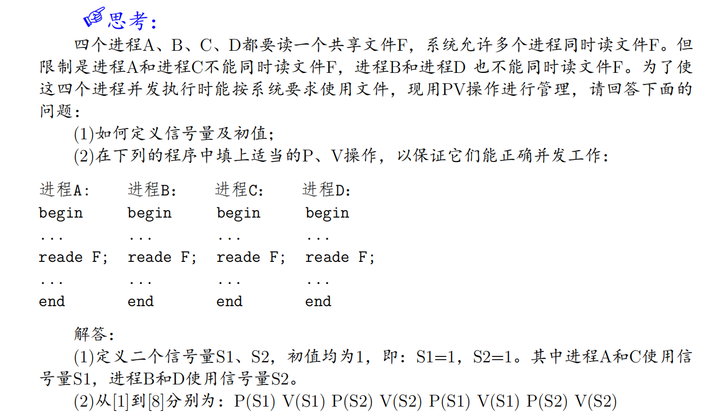

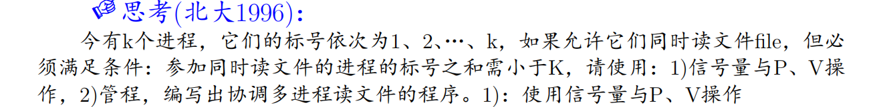

semaphore mutex = 1;      *// 互斥锁，保护共享变量*

semaphore waits = 0;      *// 阻塞等待信号量*

int number_sum = 0;       *// 当前读文件的进程标号之和*

cobegin

    procedure reader_i(int number) {

        while (1) {

            P(mutex);                *// 进入临界区*

            while (number_sum + number >= K) {  *// 循环检查条件*

                V(mutex);            *// 释放锁并等待*

                P(waits);            *// 阻塞*

                P(mutex);            *// 被唤醒后重新获取锁*

            }

            number_sum += number;    *// 更新标号和*

            V(mutex);               *// 离开临界区*

            read_file();            *// 读文件操作*

            P(mutex);               *// 进入临界区*

            number_sum -= number;   *// 减少标号和*

            V(waits);               *// 唤醒一个等待的进程*

            V(mutex);               *// 离开临界区*

        }

    }

coend

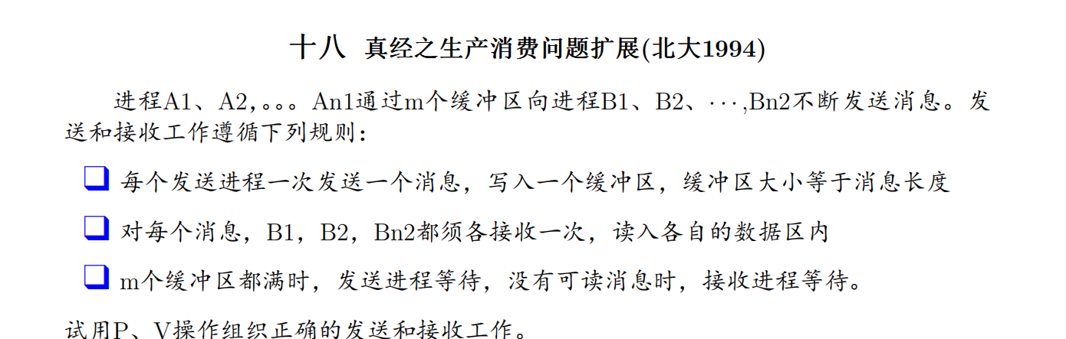

（经典的N生产者M消费者K缓冲区模型）

semaphore Sin[n2] = {m, m, ..., m};  *// 每个Bi可用的空缓冲区数量（初始全满）*

semaphore Sout[n2] = {0, 0, ..., 0}; *// 每个Bi待消费的消息数量（初始无数据）*

semaphore mutex = 1;                 *// 缓冲区互斥锁*

cobegin

procedure Aj() {  *// 发送进程*

    while (1) {

*// 检查所有Bi是否有空位（必须所有Bi都能消费才发送）*

        for (int i = 0; i < n2; i++) {

            P(Sin[i]);  *// 每个Sin[i]--，若为0则阻塞*

        }

        P(mutex);

*// 写入消息到缓冲区（所有Bi共享同一缓冲区）*

        V(mutex);

*// 通知所有Bi有新消息到达*

        for (int i = 0; i < n2; i++) {

            V(Sout[i]);  *// 每个Sout[i]++*

        }

    }

}

procedure Bi(int i) {  *// 接收进程i*

    while (1) {

        P(Sout[i]);    *// 等待属于自己的消息*

        P(mutex);

*// 从缓冲区读取消息*

        V(mutex);

        V(Sin[i]);     *// 释放一个空位*

    }

}

coend

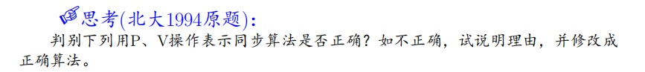

buffer[N];  *// 缓冲区*

int in = 0, out = 0;

semaphore S1 = 0;  *// 已填充计数*

semaphore S2 = N;  *// 空缓冲区计数*

cobegin

procedure producer() {

    while(1) {

*// 生产数据m;*

        P(S2);

        buffer[in] = m;

        in = (in + 1) % N;

        V(S1);

    }

}

procedure consumer() {

    while(1) {

        V(S2);  *// 错误位置！*

        m = buffer[out];

*// 消费m;*

        out = (out + 1) % N;

        P(S1);  *// 错误位置！*

    }

}

coend

正确算法：

buffer[N];  *// 缓冲区*

int in = 0, out = 0;

semaphore S1 = 0;  *// 已填充计数*

semaphore S2 = N;  *// 空缓冲区计数*

semaphore mutex = 1;  *// 互斥锁（原代码缺失）*

cobegin

procedure producer() {

    while(1) {

*// 生产数据m;*

        P(S2);

        P(mutex);

        buffer[in] = m;

        in = (in + 1) % N;

        V(mutex);

        V(S1);

    }

}

procedure consumer() {

    while(1) {

        P(S1);  *// 修正位置*

        P(mutex);

        m = buffer[out];

        out = (out + 1) % N;

        V(mutex);

        V(S2);  *// 修正位置*

*// 消费m;*

    }

}

coend

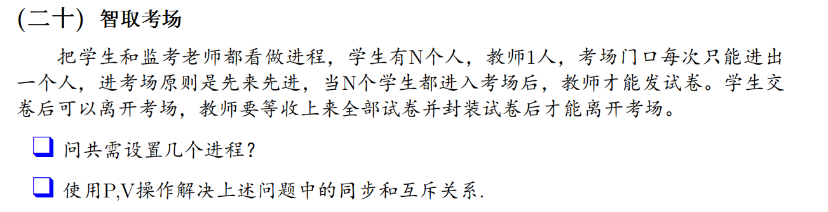

semaphore mutex = 1;           *// 互斥访问考场门口*

semaphore Beginready = -(N-1); *// 等待所有学生到达*

semaphore Testready = 0;       *// 控制发卷同步*

semaphore Endready = -(N-1);   *// 等待所有学生交卷*

cobegin

procedure Student {

    P(mutex);

    Enter;

    V(mutex);

    Waiting;

    V(Beginready);             *// 学生到达，通知教师*

    P(Testready);              *// 等待教师发卷*

    答题;

    交卷;

    离开;

    V(Endready);               *// 通知教师已交卷*

}

procedure Teacher {

    P(mutex);

    Enter;

    V(mutex);

    P(Beginready);             *// 等待所有学生到达*

    发卷;

    V(Testready);              *// 允许学生开始答题*

    P(Endready);               *// 等待所有学生交卷*

    封卷离开;

}

coend

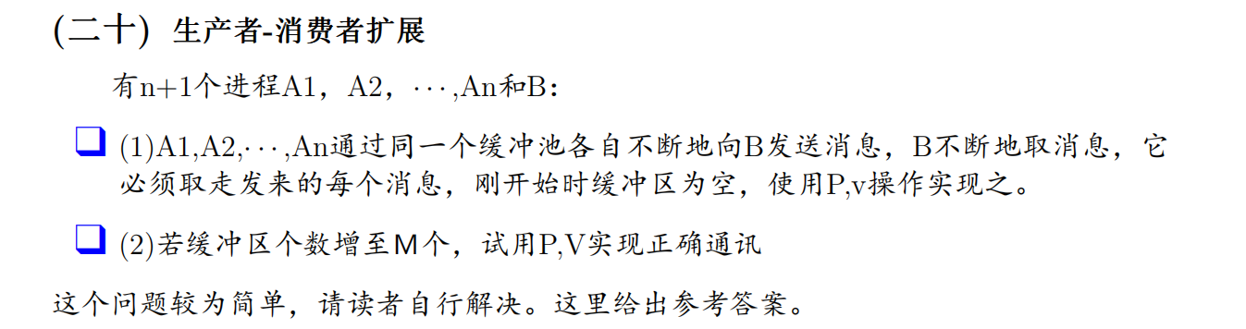

这里给出(2)的答案

semaphore empty = M;    *// 空闲缓冲区数量（初始为M）*

semaphore full = 0;     *// 已占用缓冲区数量（初始为0）*

semaphore mutex = 1;    *// 互斥锁，保护缓冲区操作*

int buffer[M];          *// 缓冲区数组*

int in = 0;             *// 生产者写入位置*

int out = 0;            *// 消费者读取位置*

cobegin

*// 生产者进程 Ai（i=1..n）*

    procedure Ai {

        while (1) {

            message = produce_message();  *// 生成消息*

            P(empty);                     *// 等待空闲缓冲区*

            P(mutex);

            buffer[in] = message;        *// 写入缓冲区*

            in = (in + 1) % M;

            V(mutex);

            V(full);                     *// 通知消费者有新消息*

        }

    }

*// 消费者进程 B*

    procedure B {

        while (1) {

            P(full);                     *// 等待有消息可读*

            P(mutex);

            message = buffer[out];       *// 读取消息*

            out = (out + 1) % M;

            V(mutex);

            V(empty);                    *// 释放缓冲区*

            consume_message(message);    *// 处理消息*

        }

    }

coend

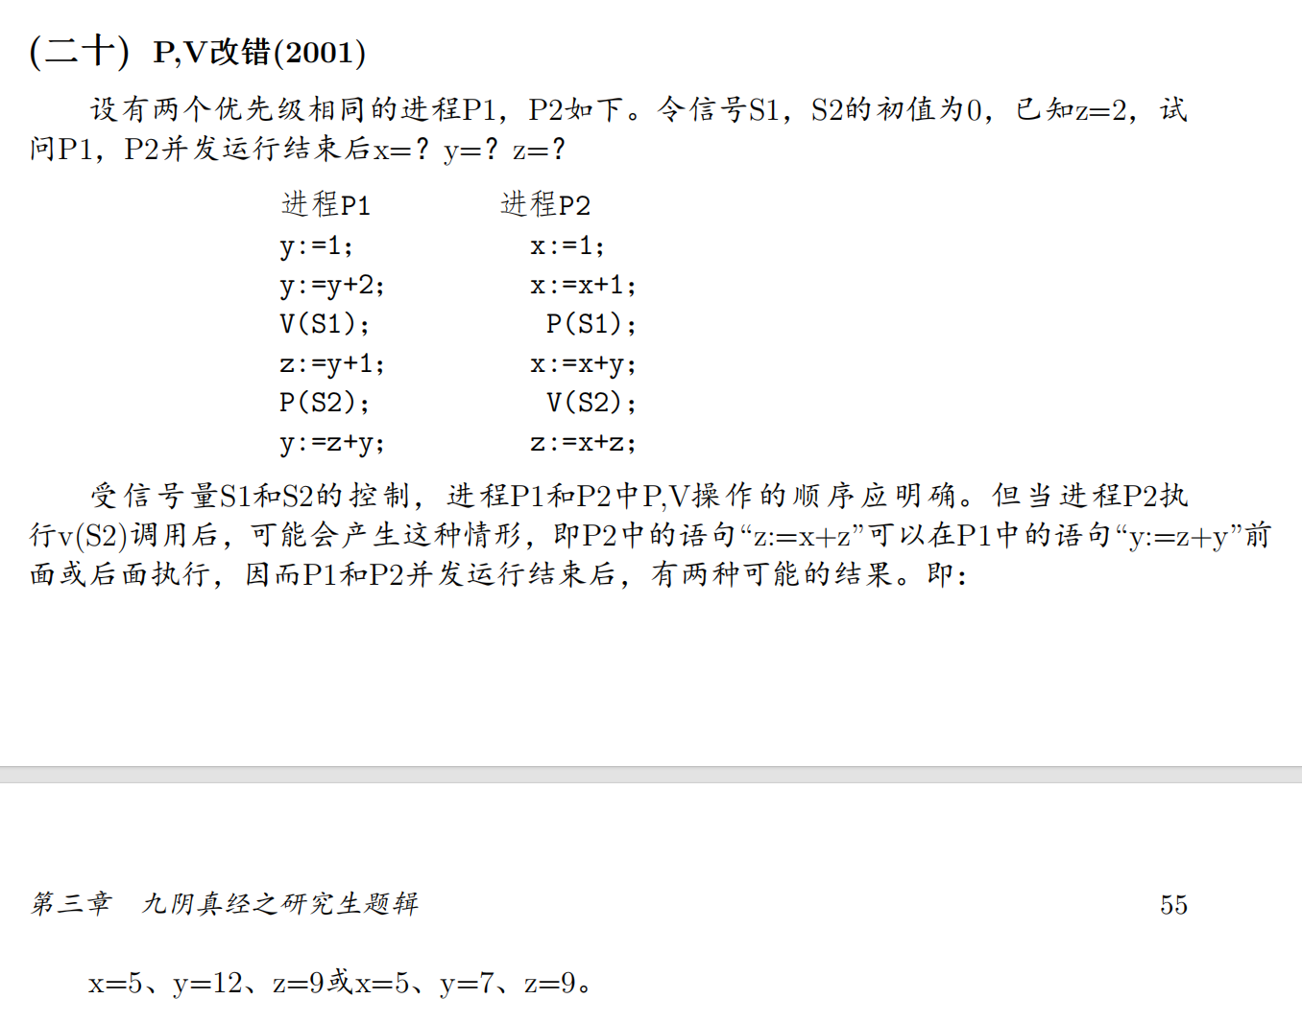

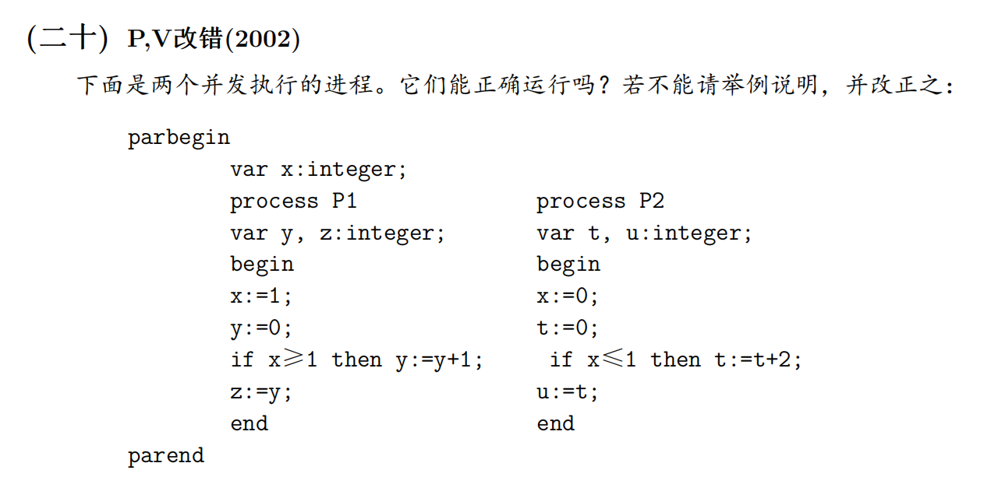

为了可读性，先将上面的错误PASCAL伪代码转化为错误的C伪代码：

int x;  *// 共享变量*

cobegin

    procedure P1 {

        int y, z;

        x = 1;

        y = 0;

        if (x >= 1) y = y + 1;

        z = y;

    }

    procedure P2 {

        int t, u;

        x = 0;

        t = 0;

        if (x <= 1) t = t + 2;

        u = t;

    }

coend

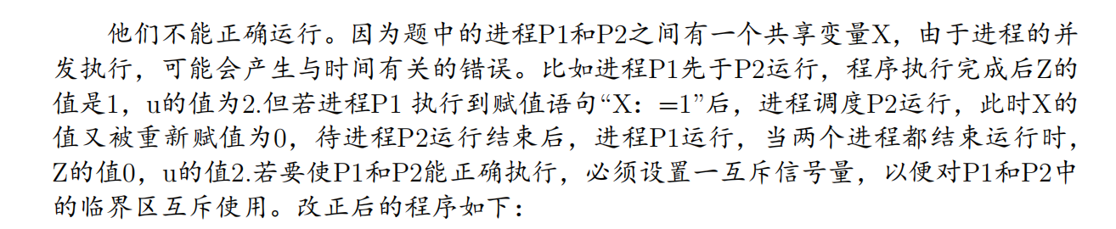

int x;                     *// 共享变量*

semaphore mutex = 1;       *// 互斥信号量*

cobegin

    procedure P1 {

        int y, z;

        P(mutex);          *// 进入临界区*

        x = 1;

        y = 0;

        if (x >= 1) y = y + 1;

        V(mutex);          *// 离开临界区*

        z = y;             *// 非临界区操作*

    }

    procedure P2 {

        int t, u;

        P(mutex);          *// 进入临界区*

        x = 0;

        t = 0;

        if (x <= 1) t = t + 2;

        V(mutex);          *// 离开临界区*

        u = t;             *// 非临界区操作*

    }

coend

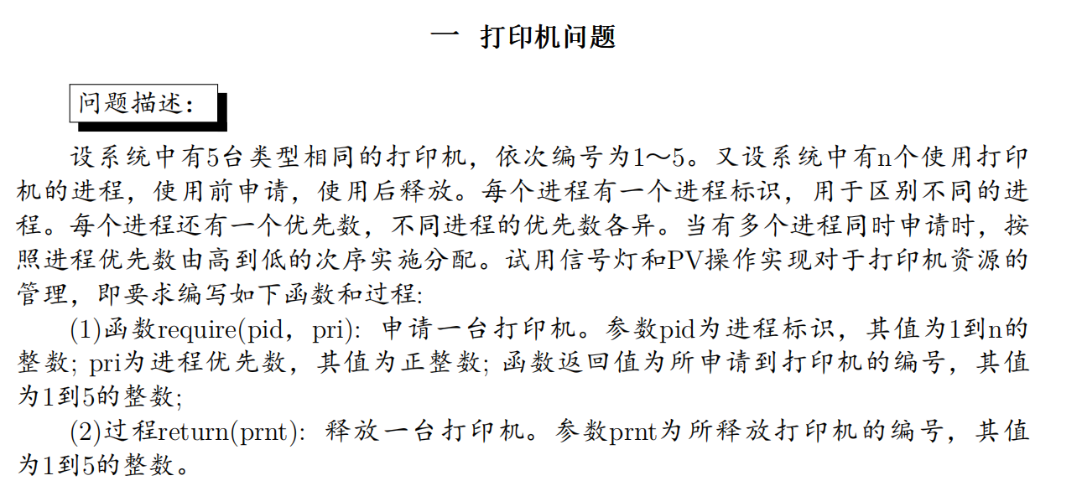

#define N 5

int flag[N+1];          *// flag[0]可用数，flag[1..5]状态*

PCB *queue = NULL;      *// 阻塞队列*

semaphore mutex_flag = 1;  *// flag互斥锁*

semaphore mutex_queue = 1; *// queue互斥锁*

cobegin

    procedure require(pid, priority) {

        P(mutex_flag);

        if (flag[0] > 0) {

            flag[0]--;

            for (int i = 1; i < N+1; i++) {

                if (flag[i] == 1) {

                    flag[i] = 0;

                    V(mutex_flag);

                    return i;

                }

            }

        } else {

            V(mutex_flag);

            P(mutex_queue);

*// 按priority将pid插入queue（需实现）*

            insert_queue_by_priority(queue, pid, priority);

            V(mutex_queue);

        }

    }

    procedure return(prnt) {

        P(mutex_flag);

        if (queue == NULL) {

            flag[0]++;

            flag[prnt] = 1;

            V(mutex_flag);

        } else {

            V(mutex_flag);

            P(mutex_queue);

*// 分配prnt给queue队首进程（需实现）*

            assign_printer(queue, prnt);

*// queue指针下移（需实现）*

            move_queue_next(queue);

            V(mutex_queue);

        }

    }

coend

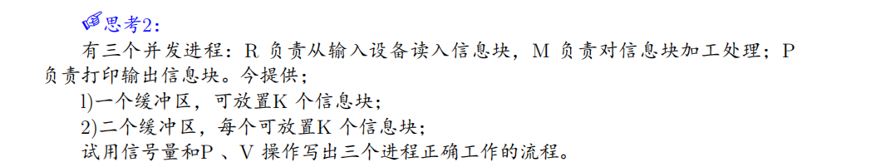

单缓冲区：

semaphore empty = K;   *// 空缓冲区数量*

semaphore full = 0;    *// 已填充缓冲区数量*

semaphore mutex = 1;   *// 互斥锁*

item buffer[K];        *// 共享缓冲区*

int in = 0, out = 0;   *// 读写指针*

cobegin

    procedure R {  *// 读进程*

        while (1) {

            item x = read_input();

            P(empty);

            P(mutex);

            buffer[in] = x;

            in = (in + 1) % K;

            V(mutex);

            V(full);

        }

    }

    procedure M {  *// 处理进程*

        while (1) {

            P(full);

            P(mutex);

            item x = buffer[out];

            out = (out + 1) % K;

            V(mutex);

            V(empty);

            x = process(x);  *// 加工处理*

*// 直接传递给P（单缓冲区无中间存储）*

            print(x);        *// 简化逻辑*

        }

    }

    procedure P {  *// 打印进程*

*// 单缓冲区时与M合并操作*

    }

coend

双缓冲区：

semaphore empty1 = K, empty2 = K;  *// 两个缓冲区的空位*

semaphore full1 = 0, full2 = 0;    *// 两个缓冲区的数据*

semaphore mutex1 = 1, mutex2 = 1;  *// 互斥锁*

item bufferA[K], bufferB[K];       *// 双缓冲区*

int put1 = 0, get1 = 0;           *// bufferA指针*

int put2 = 0, get2 = 0;           *// bufferB指针*

cobegin

    procedure R {  *// 读进程*

        while (1) {

            item x = read_input();

            P(empty1);

            P(mutex1);

            bufferA[put1] = x;

            put1 = (put1 + 1) % K;

            V(mutex1);

            V(full1);

        }

    }

    procedure M {  *// 处理进程*

        while (1) {

            P(full1);

            P(mutex1);

            item x = bufferA[get1];

            get1 = (get1 + 1) % K;

            V(mutex1);

            V(empty1);

            x = process(x);  *// 加工处理*

            P(empty2);

            P(mutex2);

            bufferB[put2] = x;

            put2 = (put2 + 1) % K;

            V(mutex2);

            V(full2);

        }

    }

    procedure P {  *// 打印进程*

        while (1) {

            P(full2);

            P(mutex2);

            item x = bufferB[get2];

            get2 = (get2 + 1) % K;

            V(mutex2);

            V(empty2);

            print(x);

        }

    }

coend

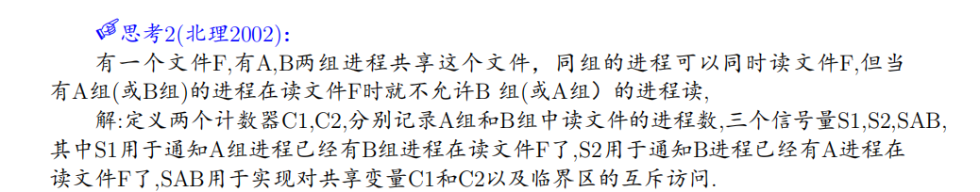

这个问题和过桥问题思路完全相同。

设某个批处理系统中，有三个进程：卡片输入进程、作业调度进程、作业控制进程。它们之间的合作关系是：

卡片输入进程：只要卡片输入机上有作业信息输入，该进程将作业逐个输入到输出井，并为每个作业建立一个JCB块（作业控制块），将其插入到后备作业队列（JCB链表）中。

作业调度进程：当内存中无作业运行时，该进程从后备作业队列中选取一个作业，将其装入内存。

作业控制进程：负责处理已调入内存的作业。

需解决的问题：

(1) 使用信号量和PV操作，写出卡片输入进程和作业调度进程的同步算法。

(2) 使用消息缓冲队列，写出作业调度进程与作业控制进程间的同步算法。

semaphore s = 1;          *// JCB队列访问控制*

semaphore mem_mutex = 1;  *// 新增：内存操作互斥锁*

semaphore io_mutex = 1;   *// 输出井访问锁（若需要）*

JCB *job_queue = NULL;    *// 后备作业队列*

cobegin

*// 卡片输入进程*

    procedure input_process {

        while (1) {

            if (has_card()) {

                P(io_mutex);              *// 保护输出井写入*

                job = read_card_to_spool();

                V(io_mutex);

                jcb = create_jcb(job);    *// 无需锁（本地操作）*

                P(s);                     *// 申请队列锁*

                insert_to_queue(&job_queue, jcb);

                V(s);

            } else {

                wait_for_card();

            }

        }

    }

*// 作业调度进程*

    procedure scheduler {

        while (1) {

            P(s);

            jcb = select_job(job_queue);  *// 选作业（临界区）*

            V(s);

            P(mem_mutex);                *// 新增：保护内存操作*

            load_to_memory(jcb);         *// 装入内存*

            V(mem_mutex);

            send_to_control(jcb);        *// 消息传递无需锁*

            wait_for_completion();

        }

    }

*// 作业控制进程*

    procedure control {

        while (1) {

            jcb = receive_from_scheduler();

            P(mem_mutex);               *// 新增：保护内存操作*

            process_job(jcb);           *// 处理内存中的作业*

            V(mem_mutex);

            send_completion_signal();

        }

    }

coend

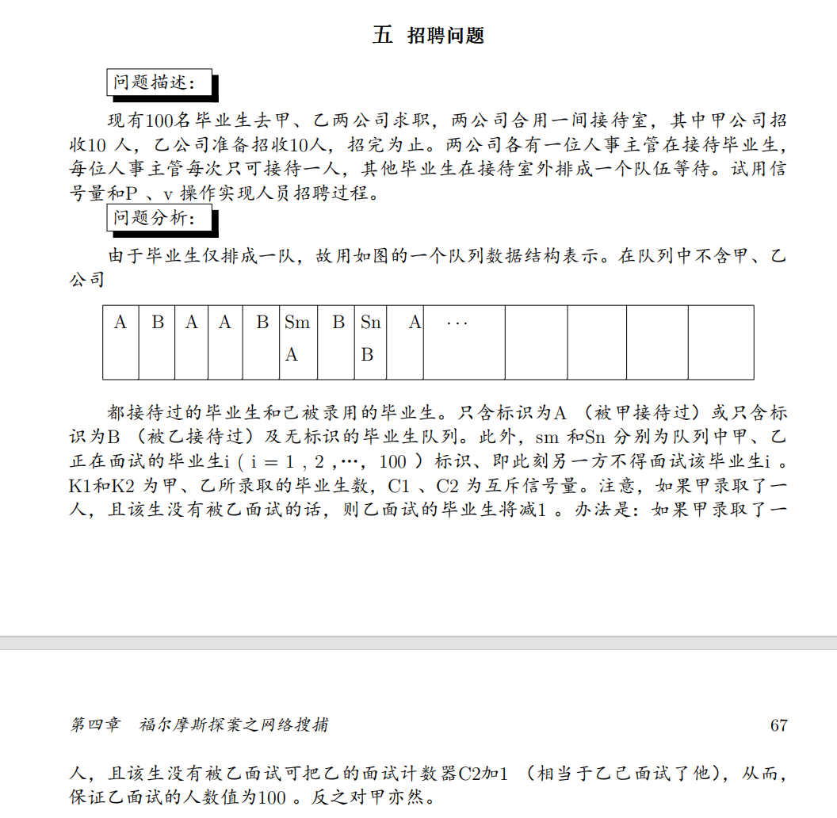

semaphore mutex = 1;    *// 队列操作锁*

int interviewed_A = 0;   *// 甲已面试人数*

int interviewed_B = 0;   *// 乙已面试人数*

int hired_A = 0;         *// 甲已录取人数*

int hired_B = 0;         *// 乙已录取人数*

*// 毕业生队列（0=未面试，1=被甲面试过，2=被乙面试过,-1=已录用）*

int queue[100] = {0};    *// 初始全未面试*

cobegin

*// 甲公司招聘*

    procedure company_A {

        while (hired_A < 10 && interviewed_A < 100) {

            P(mutex);

*// 找候选人：未被乙面试过的*

            for (i = 0; i < 100; i++) {

                if (queue[i] == 0 || queue[i] == 1) {  *// 未面试或只被甲面试过*

                    if (queue[i] == 0) interviewed_A++;

                    queue[i] = 1;  *// 标记被甲面试*

                    break;

                }

            }

            V(mutex);

*// 模拟面试*

            if (interview_pass()) {  *// 假设50%通过率*

                P(mutex);

                hired_A++;

                if (queue[i] != 2) interviewed_B++;  *// 若未被乙面试，计入乙的面试数*

                queue[i] = -1;  *// 标记为已录用*

                V(mutex);

            }

        }

    }

*// 乙公司招聘（逻辑对称）*

    procedure company_B {

        while (hired_B < 10 && interviewed_B < 100) {

            P(mutex);

            for (i = 0; i < 100; i++) {

                if (queue[i] == 0 || queue[i] == 2) {

                    if (queue[i] == 0) interviewed_B++;

                    queue[i] = 2;

                    break;

                }

            }

            V(mutex);

            if (interview_pass()) {

                P(mutex);

                hired_B++;

                if (queue[i] != 1) interviewed_A++;

                queue[i] = -1;

                V(mutex);

            }

        }

    }

coend

Jurassic公园有一个恐龙博物馆和一个花园，有m个旅客租用n辆车，每辆车仅能乘坐一名旅客。旅客在博物馆参观一段时间后，排队乘坐旅行车。当一辆车可用时，它会载入一名旅客，然后绕花园行驶任意长的时间。如果所有n辆车都已被旅客占用，则想坐车的旅客需要等待；如果一辆车已经空闲，但没有旅客等待乘车，那么车辆需要等待。试用信号量和P、V操作同步m个旅客和n辆车。

semaphore available_cars = n;  *// 当前可用车辆数（初始n辆）*

semaphore waiting_tourists = 0; *// 等待乘车的游客数*

semaphore ride_start = 0;      *// 发车许可*

semaphore ride_end = 0;        *// 下车许可*

semaphore mutex = 1;           *// 保护共享操作*

cobegin

*// 游客进程（共m个）*

    procedure tourist {

*// 等车阶段*

        P(available_cars);     *// 等空车*

        P(mutex);

        V(waiting_tourists);   *// 增加等待游客计数*

        V(mutex);

*// 乘车阶段*

        P(ride_start);         *// 等司机让上车*

        enjoy_ride();           *// 乘车游览*

        P(ride_end);            *// 等司机通知下车*

*// 下车*

        V(available_cars);      *// 释放车辆*

    }

*// 司机进程（共n个）*

    procedure driver {

        while (1) {

            P(mutex);

            if (waiting_tourists > 0) {

                P(waiting_tourists); *// 接客*

                V(ride_start);      *// 允许上车*

                V(mutex);

                drive_around();      *// 行驶*

                V(ride_end);         *// 通知下车*

            } else {

                V(mutex);

                sleep();            *// 没游客时休息*

            }

        }

    }

coend

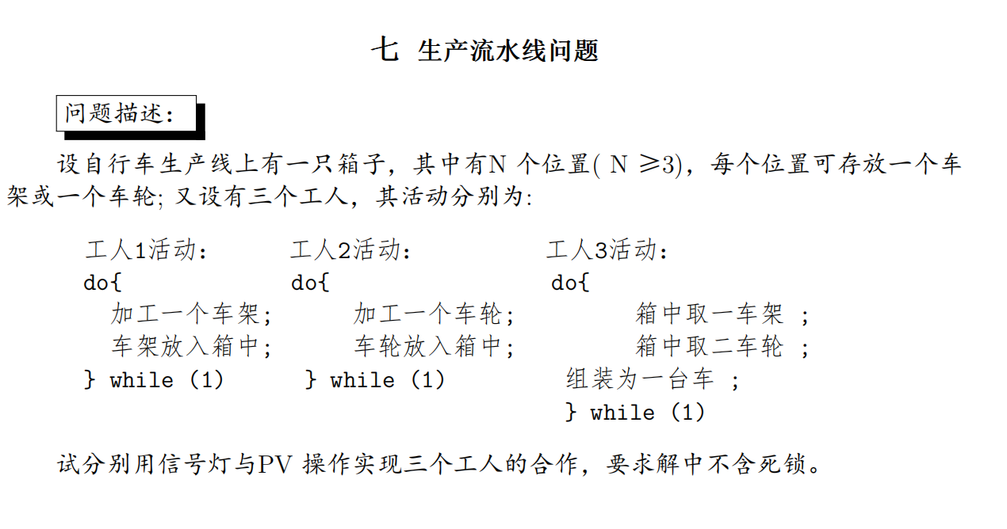

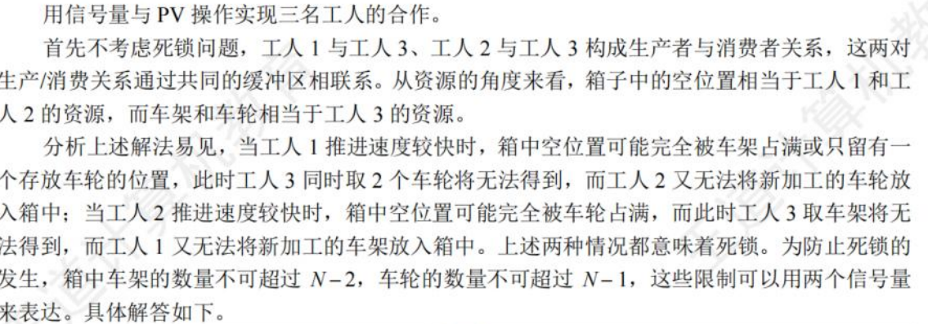

semaphore empty = N;     *// 空位置总数*

semaphore wheel = 0;     *// 当前车轮数量*

semaphore frame = 0;     *// 当前车架数量*

semaphore s1 = N-2;      *// 允许放入的车架最大数（初始N-2），同时至少留出两个空位给车轮*

semaphore s2 = N-1;      *// 允许放入的车轮最大数（初始N-1），同时至少留出一个空位给车架*

semaphore mutex = 1;     *// 箱子操作互斥锁*

cobegin

*// 工人1：生产车架*

    procedure worker1 {

        while (1) {

            加工一个车架();

            P(s1);       *// 检查车架是否可放入（不超过N-2）*

            P(empty);    *// 检查是否有空位*

            P(mutex);

            车架放入箱中();

            V(mutex);

            V(frame);    *// 车架计数+1*

        }

    }

*// 工人2：生产车轮*

    procedure worker2 {

        while (1) {

            加工一个车轮();

            P(s2);       *// 检查车轮是否可放入（不超过N-1）*

            P(empty);    *// 检查是否有空位*

            P(mutex);

            车轮放入箱中();

            V(mutex);

            V(wheel);    *// 车轮计数+1*

        }

    }

*// 工人3：组装自行车*

    procedure worker3 {

        while (1) {

            P(frame);    *// 等1个车架*

            P(mutex);

            箱中取一车架();

            V(mutex);

            V(empty);    *// 释放1空位*

            V(s1);       *// 允许放入的车架数+1*

            P(wheel);    *// 等第1个车轮*

            P(wheel);    *// 等第2个车轮*

            P(mutex);

            箱中取二车轮();

            V(mutex);

            V(empty);    *// 释放1空位（第1个车轮）*

            V(empty);    *// 释放1空位（第2个车轮）*

            V(s2);       *// 允许放入的车轮数+1（第1个车轮）*

            V(s2);       *// 允许放入的车轮数+1（第2个车轮）*

            组装为一台车();

        }

    }

coend

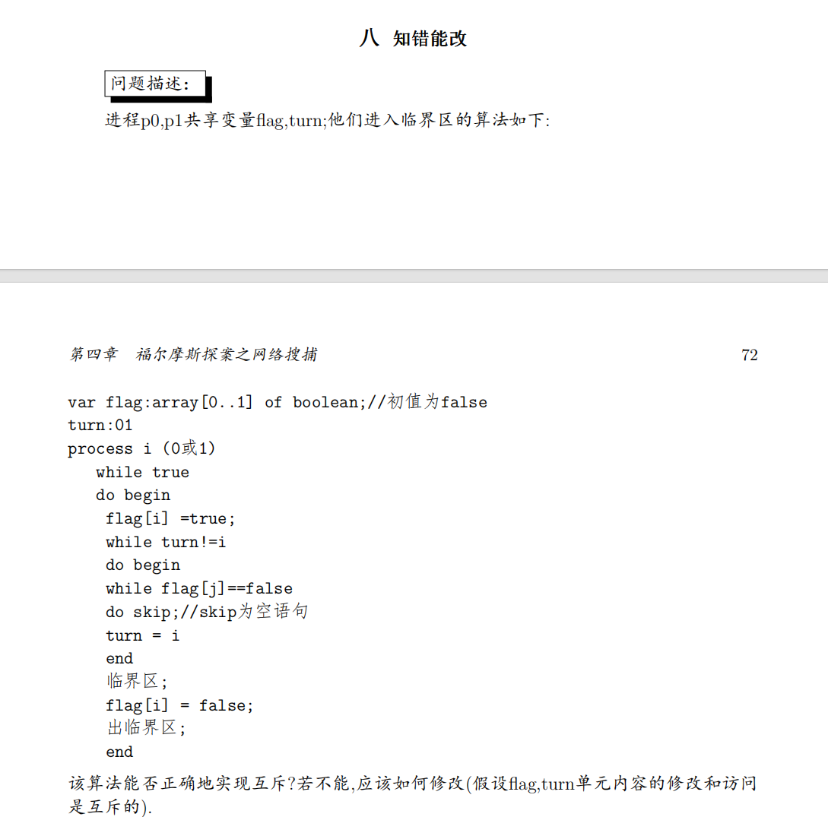

为了可读性，先将错误的PASCAL转化为错误的C语言伪代码:

bool flag[2] = {false, false};  *// 共享变量，初始化为 false*

int turn = 0;                   *// 共享变量，初始化为 0*

procedure process(int i) {      *// i 为 0 或 1*

    while (1) {                 *// 无限循环*

        flag[i] = true;         *// 表示进程 i 想进入临界区*

        while (turn != i) {     *// 如果当前轮次不是 i*

            while (!flag[1-i]);*// 检查对方是否不想进入*

            turn = i;           *// 强行夺取轮次*

        }

*/* 临界区 */*           *// 进入临界区*

        flag[i] = false;        *// 退出临界区*

*/* 剩余区 */*

    }

}

*// 进程启动*

cobegin

    process(0);

    process(1);

coend

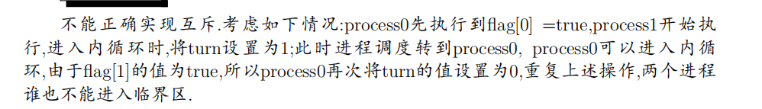

正确的C伪代码:

bool flag[2] = {false, false}; *// 表示进程是否想进入临界区*

int turn = 0;                   *// 表示当前允许进入的进程*

procedure process(int i) {      *// i 为 0 或 1*

    while (1) {

        flag[i] = true;         *// 表示进程 i 想进入临界区*

        turn = 1 - i;           *// 谦让给对方*

        while (flag[1-i] && turn == 1-i)；

*/* 临界区 */*           *// 进入临界区*

        flag[i] = false;        *// 退出临界区*

*/* 剩余区 */*

    }

}

*// 启动进程*

cobegin

    process(0);

    process(1);

coend

补充生产者消费者问题：（820有类似的）  
 有一个大小为2的缓冲区，进程P1每次用put_odd()向缓冲区中放入一个奇数，进程P2每次用put_even()向缓冲区中放入一个偶数，进程P3每次用get_data()从缓冲区中同时取走奇数和偶数，即仅当缓冲区中同时存在奇数和偶数时(不要被这句话迷惑了，不需要if!!P两次就行)，进程P3才能从缓冲区中取走数据。每次只能有一个进程访问缓冲区。请用信号量机制，P、V原语（或wait、signal操作）实现这三个进程的同步与互斥活动，并说明各个信号量的具体含义，要求用伪代码实现。(12分)  
semaphore mutex = 1; *//互斥信号量，实现对缓冲区的互斥操作，初值为1。（1分）*

semaphore empty_odd = 1; *//资源信号量，缓冲区中可以放奇数的单元数，初值为1。（1分）*

semaphore empty_even = 1; *//资源信号量，缓冲区中可以放偶数的单元数，初值为1。（1分）*

semaphore data_odd = 0; *//资源信号量，缓冲区中奇数的个数，初值为0。（1分）*

semaphore data_even = 0; *//资源信号量，缓冲区中偶数的个数，初值为0。（1分）*

P1( ) （2分）

{

    while(true)

        {

            P(empty_odd);

            P(mutex);

            Put_odd()；

            V(mutex);

            V(data_odd);

        }

     }

P2( ) （2分）

{

    while(true)

        {

            P(empty_even);

            P(mutex);

            Put_even()；

            V(mutex);

            V(data_even);

        }

     }

P3( ) （3分）

{

    while(true)

        {

            P(data_odd);*//不需要if判断！！！*

P(data_even);

            P(mutex);

             Get_data()；

    V(mutex);

V(empty_odd);

            V(empty_even);

        }

     }

main ( )

{

    cobegin

        P1( );

        P2( );

        P3( );

}

//也可以设置semaphore empty=2,但是最后的话要V(empty)两次！！！

